TRAVEL BLOG COMMUNITY
@CREATIVITY THINK (9483175986/7019689991)

ABSTRACT:
The Travel Blog Community is a web-based platform designed to enable users to share travel experiences, create blog posts, integrate maps, and interact in groups. The platform allows bloggers, students, and travel enthusiasts to document journeys, add photos, and provide location-based content. Administrators can moderate posts, manage travel topics, and view dashboard analytics. Developed with Django and Django Rest Framework for backend operations and React with axios and Leaflet for frontend map integration, the system provides a secure, interactive, and engaging environment for travel content sharing and community collaboration..

INTRODUCTION OF THE PROJECT:
Many travel enthusiasts and bloggers struggle to find centralized platforms to share their experiences and collaborate with like-minded users. Traditional blogging platforms may not support map integration or community-based interactions effectively. The Travel Blog Community addresses these challenges by providing a dedicated space for users to write blogs, embed maps, join travel groups, and interact through comments and likes. Administrators can monitor content, manage topics, and generate analytics, ensuring the platform is engaging, safe, and informative..

PROJECT OBJECTIVES:

• Enable users to create and publish travel blogs
• Allow users to add photos, maps, and location-based content
• Provide group-based collaboration for travel enthusiasts
• Track engagement through dashboard analytics
• Allow administrators to moderate posts and manage topics
• Ensure secure and scalable backend operations
• Enable commenting, liking, and user interaction
• Support an intuitive, user-friendly interface for content creation

PROBLEM OF THE STATEMENT:
Travel bloggers and communities often face difficulties in sharing geographically relevant content, interacting in groups, and receiving real-time analytics on engagement. Existing platforms either lack map integration or community collaboration features. Administrators also face challenges in moderating content and tracking overall engagement. The Travel Blog Community solves these issues by integrating blogging, map visualization, community interaction, and administrative analytics into a single platform..

MOTIVATION OF THE PROJECT:
• To provide a dedicated platform for travel content sharing
• To integrate maps and location-based storytelling
• To foster community engagement through group collaborations
• To enable admins to moderate posts and topics efficiently
• To provide dashboard insights for user activity and engagement
• To make travel blogging interactive and organized
• To promote travel awareness and community learning

BLOCK DAIGRAM OF PROJECT:

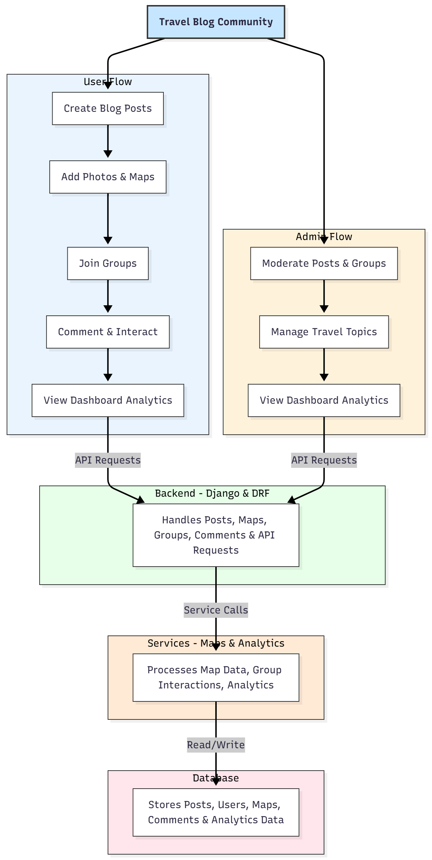

WORKING OF THE PROJECT:
Users can create travel blogs, upload photos, and add map locations for visual storytelling. They can join travel groups, comment on posts, and interact with other members. The backend processes all content, handles API requests, stores user activity, and manages map data. Administrators can moderate content, manage travel topics, and analyze engagement through dashboards. All user interactions, posts, and analytics data are stored securely in the database. Services like map processing and analytics ensure real-time updates and insights, providing a dynamic and collaborative experience..

SOFTWARE REQUIREMENT:
- Backend:
  - Python 3.x
  - Django
  - Django REST Framework
  - SQLite/PostgreSQL
- Frontend:
  - Node.js and npm
  - React.js
  - Axios
- Development Tools:
  - Visual Studio Code
  - Postman (for testing APIs)
  - Git/GitHub (for version control)
- Server/Deployment (Optional):
  - Gunicorn, Nginx, or Heroku/AWS for hosting

ADVANTAGES OF THE PROJECT:

• Centralized platform for travel content sharing
• Map-based visual storytelling
• Community engagement through groups and comments
• Dashboard analytics for user activity
• Admin moderation for safe content management
• Real-time updates and interactive experience
• Secure storage of posts, maps, and comments
• Scalable for large blogging communities

APPLICATIONS OF THE PROJECT:
• Travel bloggers and enthusiasts
• Travel agencies
• Students documenting trips
• Cultural and exploration communities
• Tourism promotion organizations
• Educational travel projects

REFERENCES:

- Django REST Framework Documentation — Django Software Foundation. Django Documentation. Available: https://docs.djangoproject.com/
- Django REST Framework. DRF Documentation. Available: https://www.django-rest-framework.org/
- React. React Official Documentation. Available: https://reactjs.org/docs/getting-started.html
- Redux. Redux Documentation. Available: https://redux.js.org/introduction/getting-started
- PostgreSQL Global Development Group. PostgreSQL Documentation. Available: https://www.postgresql.org/docs/
- MySQL. MySQL Reference Manual. Available: https://dev.mysql.com/doc/
- Git. Git Documentation. Available: https://git-scm.com/doc
- Node.js. Node.js Documentation. Available: https://nodejs.org/en/docs/
- Axios. Axios Documentation. Available: https://axios-http.com/docs/intro
- Socket.io Documentation – https://socket.io/docs/

